**Problem 1**

**package problem1;**

**import java.awt.*;**

**import java.text.DecimalFormat;**

**import javax.swing.*;**

**import javax.swing.border.EmptyBorder;**

**public class Solution1 extends JFrame {**

**private JTextField txtMille;**

**private JTextField txtPound;**

**private JTextField txtGallon;**

**private JTextField txtFhrenheit;**

**private JTextField txtKilometer;**

**private JTextField txtKilogram;**

**private JTextField txtLitre;**

**private JTextField textCentigrade;**

**final String TITLE = "UNIT CONVERSOR";**

**public static final int DEFAULT_WIDTH = 470;**

**public static final int DEFAULT_HEIGHT = 350;**

**public static void main(String[] args) {**

**Solution1 frame = new Solution1();**

**frame.setVisible(true);**

**}**

**public Solution1() {**

**JButton btnConvert = new JButton("Convert");**

**btnConvert.setBounds(170, 208, 100, 70);**

**this.setSize(DEFAULT_WIDTH, DEFAULT_HEIGHT);**

**this.getContentPane().setLayout(null);**

**this.setLayout(null);**

**JLabel lblMile = new JLabel("Mile:");**

**JLabel lblPound = new JLabel("Pound:");**

**JLabel lblGallon = new JLabel("Gallon:");**

**JLabel lblFahrenheit = new JLabel("Fahrenheit:");**

**txtPound = new JTextField();**

**txtGallon = new JTextField();**

**txtFhrenheit = new JTextField();**

**JLabel lblKilometer = new JLabel("Kilometer");**

**JLabel lblKilogram = new JLabel("Kilogram");**

**JLabel lblLitre = new JLabel("Litre");**

**JLabel lblCentigrade = new JLabel("Centigrade");**

**txtKilometer = new JTextField();**

**txtLitre = new JTextField();**

**textCentigrade = new JTextField();**

**txtKilogram = new JTextField();**

**lblMile.setBounds(10, 36, 69, 22);**

**lblPound.setBounds(10, 78, 69, 22);**

**lblGallon.setBounds(10, 120, 69, 22);**

**lblFahrenheit.setBounds(10, 162, 69, 22);**

**txtMille = new JTextField();**

**txtMille.setBounds(89, 36, 108, 22);**

**txtMille.setColumns(10);**

**txtPound.setBounds(87, 78, 110, 22);**

**txtPound.setColumns(10);**

**txtGallon.setBounds(89, 120, 108, 22);**

**txtGallon.setColumns(10);**

**txtFhrenheit.setBounds(89, 162, 108, 22);**

**txtFhrenheit.setColumns(10);**

**lblKilometer.setBounds(226, 36, 79, 22);**

**lblKilogram.setBounds(226, 78, 79, 22);**

**lblLitre.setBounds(226, 120, 79, 22);**

**lblCentigrade.setBounds(226, 162, 79, 22);**

**txtKilometer.setBounds(315, 36, 109, 22);**

**txtKilometer.setColumns(10);**

**txtKilogram.setBounds(315, 78, 109, 22);**

**txtKilogram.setColumns(10);**

**txtLitre.setBounds(315, 120, 109, 22);**

**txtLitre.setColumns(10);**

**textCentigrade.setBounds(315, 162, 109, 22);**

**textCentigrade.setColumns(10);**

**txtMille.setText("0");**

**txtPound.setText("0");**

**txtGallon.setText("0");**

**txtFhrenheit.setText("0");**

**txtKilometer.setText("0");**

**txtKilogram.setText("0");**

**txtLitre.setText("0");**

**textCentigrade.setText("0");**

**btnConvert.addActionListener(evt -> {**

**double tmpMile = 0;**

**double tempPound = 0;**

**double tempGallon = 0;**

**double tempFahrenheit = 0;**

**double tempKilometer = 0;**

**double tempKilogram = 0;**

**double tempLitre = 0;**

**double tempCentigrade = 0;**

**if (!txtMille.getText().chars().allMatch(x -> ((Character.isDigit(x) || x==',' || x=='.' ) ? true : false) ) )**

**{**

**tmpMile = 0;**

**JOptionPane.showMessageDialog(null, "Upss :( Mile must be number. Check it. ");**

**} else {**

**tmpMile = ConvertToNumber(txtMille.getText());**

**}**

**if (!txtPound.getText().chars().allMatch(x ->((Character.isDigit(x) || x==',' || x=='.' ) ? true : false)) ) {**

**tempPound = 0;**

**JOptionPane.showMessageDialog(null, "Upss :( Pound must be number. Check it. ");**

**}**

**else {**

**tempPound = ConvertToNumber(txtPound.getText());**

**}**

**if (! txtGallon.getText().chars().allMatch(x ->((Character.isDigit(x) || x==',' || x=='.' ) ? true : false)) ) {**

**tempGallon = 0;**

**JOptionPane.showMessageDialog(null, "Upss :( Gallon must be number. Check it. ");**

**}**

**else {**

**tempGallon = ConvertToNumber( txtGallon.getText());**

**}**

**if (!txtFhrenheit.getText().chars().allMatch(x ->((Character.isDigit(x) || x==',' || x=='.' ) ? true : false)) ) {**

**tempFahrenheit = 0;**

**JOptionPane.showMessageDialog(null, "Upss :( Fahrenheit must be number. Check it. ");**

**}**

**else {**

**tempFahrenheit = ConvertToNumber(txtFhrenheit.getText());**

**}**

**if (!txtKilometer.getText().chars().allMatch(x ->((Character.isDigit(x) || x==',' || x=='.' ) ? true : false)) ) {**

**tempKilometer = 0;**

**JOptionPane.showMessageDialog(null, "Upss :( Kilometer must be number. Check it. ");**

**}**

**else {**

**tempKilometer = ConvertToNumber(txtKilometer.getText());**

**}**

**if (!txtKilogram.getText().chars().allMatch(x ->((Character.isDigit(x) || x==',' || x=='.' ) ? true : false)) ) {**

**tempKilogram = 0;**

**JOptionPane.showMessageDialog(null, "Upss :( Kilogram must be number. Check it. ");**

**}**

**else {**

**tempKilogram = ConvertToNumber(txtKilogram.getText());**

**}**

**if (!txtLitre.getText().chars().allMatch(x ->((Character.isDigit(x) || x==',' || x=='.' ) ? true : false)) ) {**

**tempLitre = 0;**

**JOptionPane.showMessageDialog(null, "Upss :( Litre must be number. Check it. ");**

**}**

**else {**

**tempLitre = ConvertToNumber(txtLitre.getText());**

**}**

**if (!textCentigrade.getText().matches("\\d+(\\.\\d+)?")) {**

**tempCentigrade = 0;**

**JOptionPane.showMessageDialog(null, "Upss :( Centigrade must be number. Check it. ");**

**}**

**else {**

**tempCentigrade = ConvertToNumber(textCentigrade.getText());**

**}**

**if (tmpMile == 0 && tempKilometer > 0)**

**{**

**tmpMile = 0.62 * tempKilometer;**

**}**

**else if (tmpMile > 0 && tempKilometer == 0)**

**{**

**tempKilometer = 1.6 * tmpMile;**

**}**

**else**

**{**

**tmpMile = 0.62 * tempKilometer;**

**tempKilometer = 1.6 * tmpMile;**

**}**

**if (tempPound == 0 && tempKilogram > 0)**

**{**

**tempPound = 2.2 * tempKilogram;**

**} else if (tempPound > 0 && tempKilogram == 0) {**

**tempKilogram = 0.45 * tempPound;**

**}**

**if (tempGallon == 0 && tempLitre > 0)**

**{**

**tempGallon = 0.264 * tempLitre;**

**}**

**else if (tempGallon > 0 && tempLitre == 0)**

**{**

**tempLitre = 3.785 * tempGallon;**

**}**

**if (tempFahrenheit == 0 && tempCentigrade > 0) {**

**tempFahrenheit = (tempCentigrade * 1.8) + 32;**

**}**

**else if (tempFahrenheit > 0 && tempCentigrade == 0)**

**{**

**tempCentigrade = (tempFahrenheit - 32) / 1.8;**

**}**

**else {**

**tempFahrenheit = (tempCentigrade * 1.8) + 32;**

**tempCentigrade = (tempFahrenheit - 32) / 1.8;**

**}**

**txtMille.setText(simpleFormat(tmpMile));**

**txtGallon.setText(simpleFormat(tempGallon));**

**txtFhrenheit.setText(simpleFormat(tempFahrenheit));**

**txtLitre.setText(simpleFormat(tempLitre));**

**textCentigrade.setText(simpleFormat(tempCentigrade));**

**txtKilometer.setText(simpleFormat(tempKilometer));**

**txtKilogram.setText(simpleFormat(tempKilogram));**

**txtPound.setText(simpleFormat(tempPound));**

**}**

**);**

**this.add(btnConvert);**

**this.setTitle(TITLE);**

**this.setDefaultCloseOperation(JFrame.EXIT_ON_CLOSE);**

**this.add(textCentigrade);**

**this.add(txtLitre);**

**this.add(txtKilogram);**

**this.add(txtKilometer);**

**this.add(lblCentigrade);**

**this.add(lblLitre);**

**this.add(lblKilogram);**

**this.add(lblKilometer);**

**this.add(txtFhrenheit);**

**this.add(txtGallon);**

**this.add(txtPound);**

**this.add(txtMille);**

**this.add(lblFahrenheit);**

**this.add(lblGallon);**

**this.add(lblPound);**

**this.add(lblMile);**

**}**

**public Double ConvertToNumber(String number)**

**{**

**number=number.replace(",", ".");**

**number=number.replace(" ", "");**

**try {**

**return Double.parseDouble(number);**

**}**

**catch (Exception e)**

**{**

**try {**

**Float f = Float.parseFloat(number);**

**Double d = new Double(f.toString());**

**return d ;**

**} catch (Exception e2)**

**{**

**return Double.parseDouble("-999999999999999");**

**}**

**}**

**}**

**public String simpleFormat(double number) {**

**DecimalFormat df = new DecimalFormat("#.##");**

**return df.format(number);**

**}**

**}**

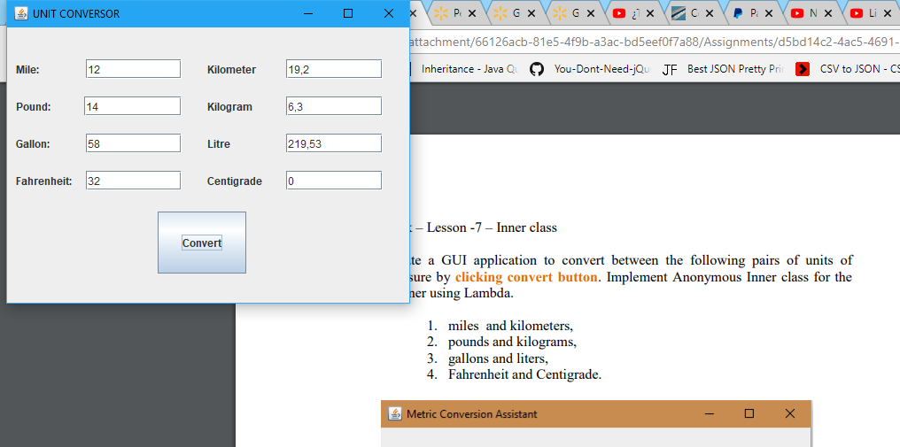

**Problem 2**

**package** problem2;

**public** **class** MyTable {

**private** Entry[] entries= **new** Entry[26];

**private** **final** String alphabet="abcdefghijklmnopqrstuvwxyz";

// returns the String that is matched with char c in the table

**public** String get(**char** c)

{

**int** index=**this**.alphabet.indexOf(c);

Entry result = **this**.entries[index];

**return** result.str;

}

// adds to the table a pair (c, s) so that s can be looked up using c

**public** **void** add(**char** c, String s) {

**int** index=**this**.alphabet.indexOf(c);

**this**.entries[index]=**new** Entry(c, s);

}

// returns a String consisting of nicely formatted display

// of the contents of the table

**public** String toString() {

StringBuilder builder = **new** StringBuilder();

**for** (Entry entry : entries)

{

**if** (entry!=**null**)

{

builder.append(entry.toString()+"\n");

}

}

**return** builder.toString();

}

**private** **class** Entry {

**char** ch; String str;

Entry(**char** ch, String str)

{

**this**.ch=ch;

**this**.str=str;

}

**public** String toString() {

alphabet.equals("3");

StringBuilder builder = **new** StringBuilder();

builder.append(**this**.ch);

builder.append("->");

builder.append(**this**.str);

**return** builder.toString();

}

}

**public** **static** **void** main(String[] args) {

MyTable t = **new** MyTable();

t.add('a', "Andrew");

t.add('b',"Billy");

t.add('c',"Charlie");

String s = t.get('b');

System.***out***.println(s);

System.***out***.println(t);

//output

}

}

